Anil Linux Task Day-01
1.Install Ubuntu Linux either on VirtualBox, VMware, or via WSL and ensure you can successfully log in using terminal access.
I have worked in VMware and installed ubuntu, while installing the ubuntu OS I have set up the storage, network, time and date. After completion of installation login with user id and password.
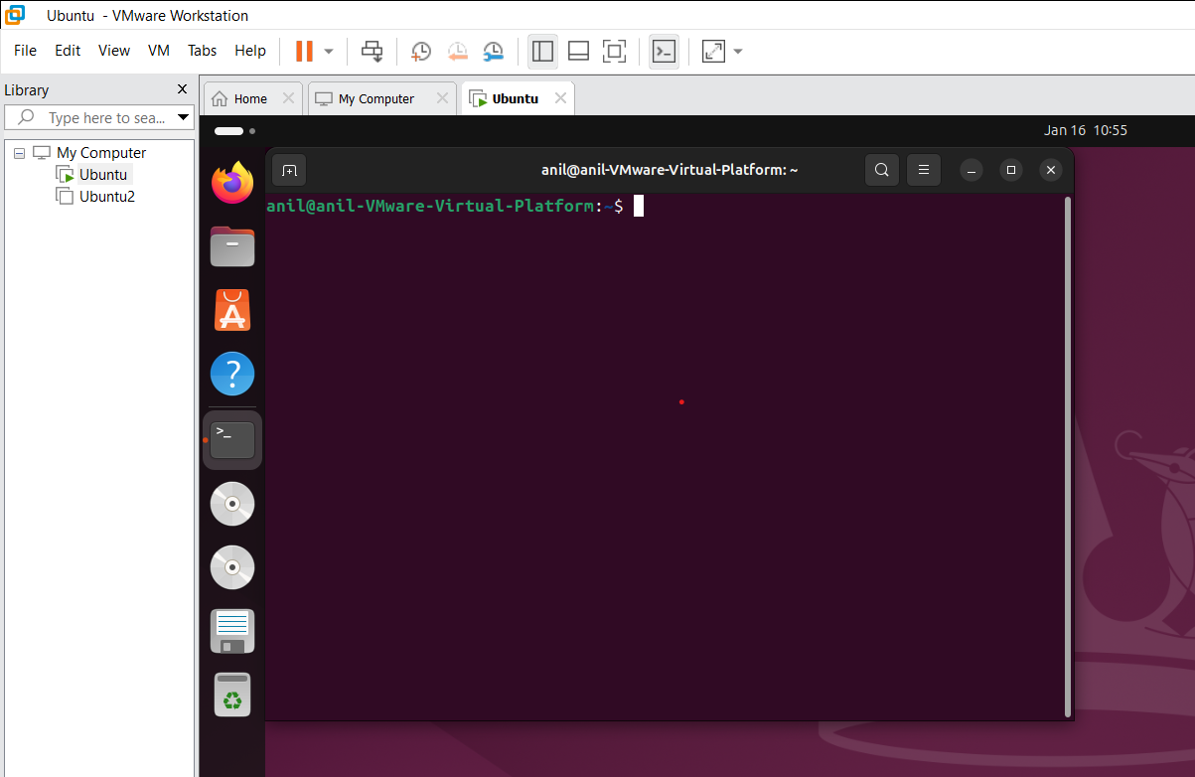

2.Explore directory structure using commands like pwd, ls, cd, and understand root vs home directory.
Pwd :-It shows present working directory
Ls :- It shows listing all file names
CD :- It changes the directory
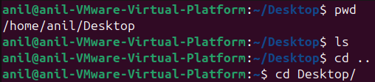
Su- It change the user to root directory
Home:- it stores normal user’s home directories, personal files, documents and also default working directory after login users.
Root:- It stores root user’s personal files used for administration tasks.

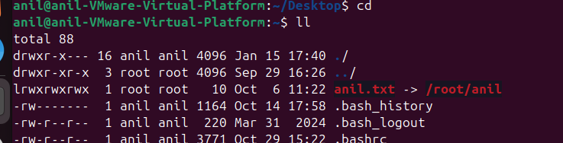

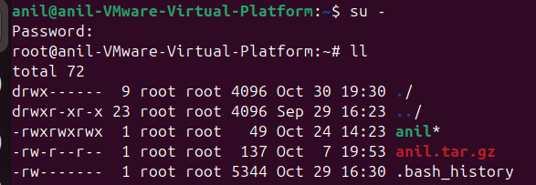
3.Create directories and files using mkdir, touch, and remove them safely using rm, rmdir.
Mkdir:- it creates new directory
Touch:- it creates new empty file
Remove:- we have removed any file are directory we can use rm rmdir
Rm;- It removes file
Rmdir:- It removes empty directory

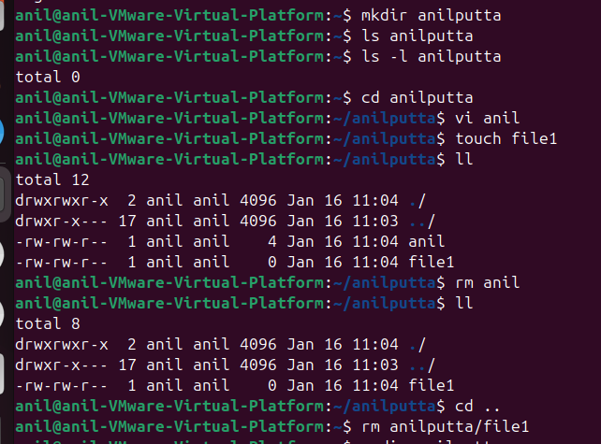

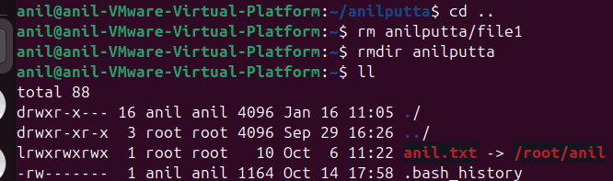

4.Practice file viewing and editing using cat, less, nano, or vim editors.
Cat:- cat command displays the content of a file
Less:- it is also view files page by page
Nano :- it one of the editor and it will display the options to use the nano editor
Vim editor:- most of the user are used this editor it easy to use and edit the file
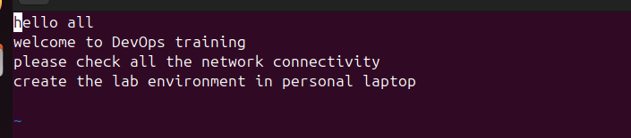
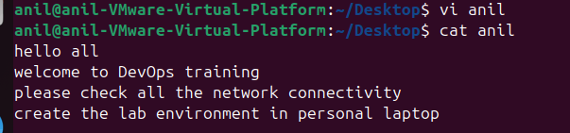
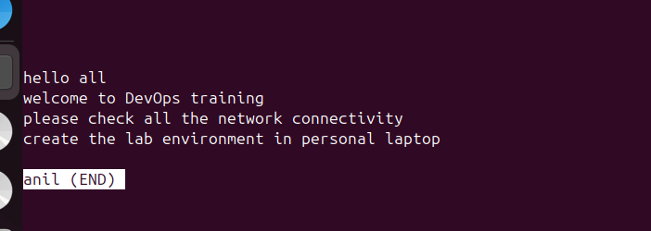

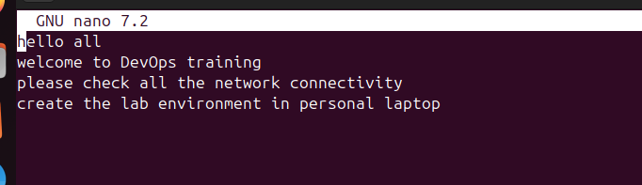
5.Understand file permissions by running ls -l and modifying permissions using chmod and ownership using chown.
Ls -l:- it display the file permission, ownership, time and date of the file
Chmod :- it can change the file permission like read write execute permission
Chown:- it can change the ownership of the file
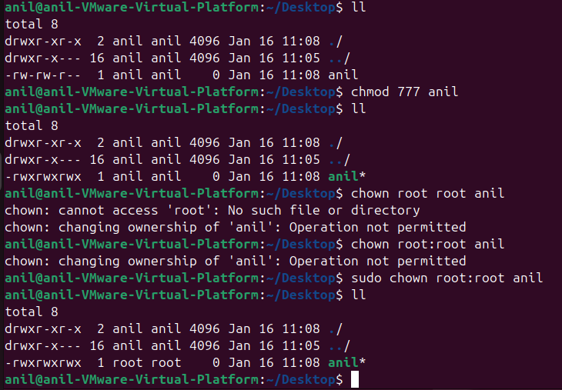
6.Learn system monitoring basics with top, htop, df -h, and free -m
Top:- it displays the memory cpu and ram usage of the system and also shows the process
Htop:- it show cpu, memory and swap usage
Df -h:-it displays the filesystem used memory and free space
Free -m :- it displays the free memory and swap memory

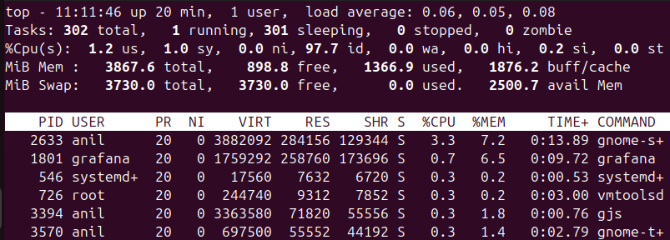

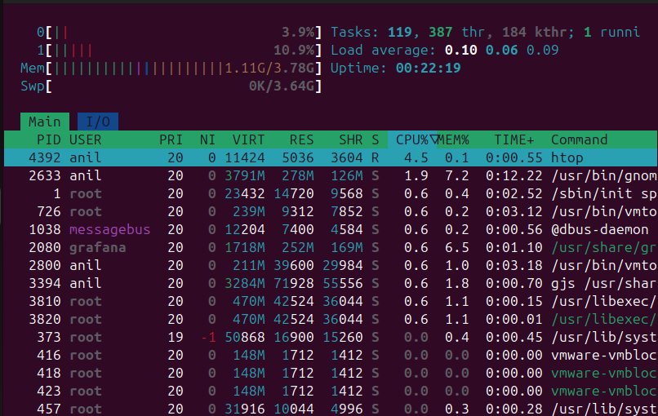

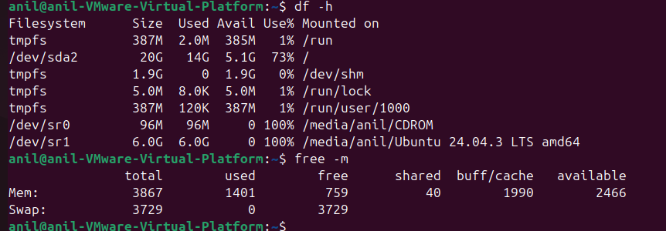

pwd
75 ls
76 cd
77 cd Desktop/
78 sudo
79 clear
80 pwd
81 ls
82 cd ..
83 cd Desktop/
84 sudo root
85 cd
86 ll
87 sudo /root
88 su -
89 mkdir anilputta
90 ls anilputta
91 ls -l anilputta
92 cd anilputta
93 vi anil
94 touch file1
95 ll
96 rm anil
97 ll
98 cd ..
99 rm anilputta/file1
100 rmdir anilputta
101 ll
102 cd Desktop/
103 ll
104 touch anil
105 ll
106 chmod 777 anil
107 ll
108 chown root root anil
109 chown root:root anil
110 sudo chown root:root anil
111 ll
112 cd
113 top
114 htop
115 apt install htop
116 sudo apt install htop
117 htop
118 df -h
119 free -m

Day-02
1.Install Git and configure username and email globally on your system.
I install the git with using the apt install git
After installed the we have check the git -v it shows the git version
Then we have to config the git locally by using the
git config –config user.name “anilputta”
git config – config user.email “anilputta916@gmail.com”
git config –list
it will show git configuration
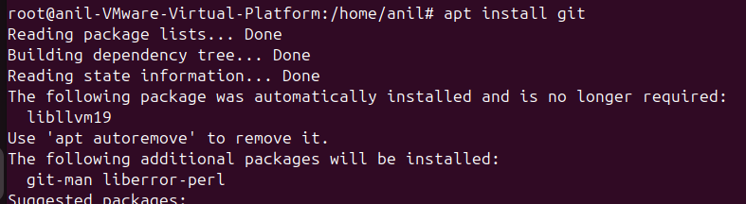
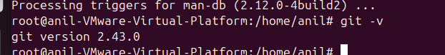

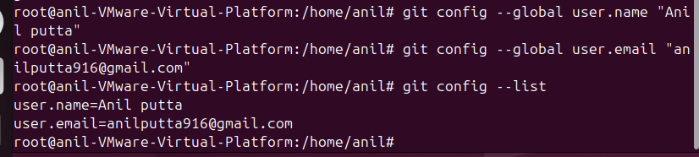
2.Initialize a local Git repository and understand .git directory purpose.
We can initialize local git repository first we can create a directory mkdir git-demo
Cd git-demo
git init
it create initialize new local directory
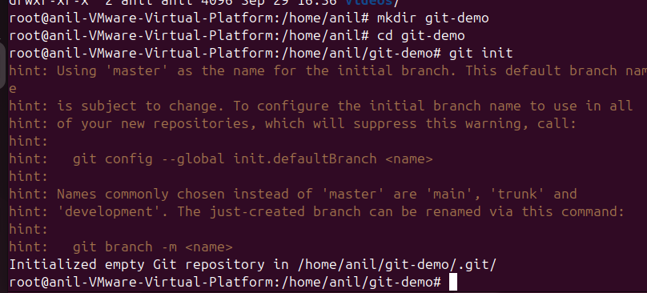
3.Create files and track changes using git status, git add, git commit.
We can create file using the echo “my first git file” > file1.txt
We can check the git status it will show the file add, remove or modify status
git add file1.txt the add file to staging
git commit -m “initial commit” it is used to save changes from the staging area into repository history
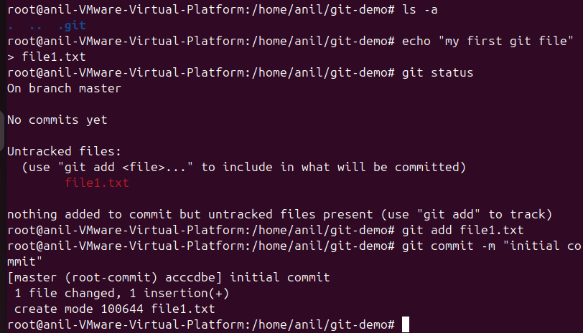
4.Create a GitHub repository and link it with local repo using SSH/HTTPS.
We can copy the ssh key in github repository and use in local
Git remote add origin add origin git@github.com:Anil-Putta/AnilDevOps.git
This command is used to add the git repo in local
Git remote -v it will show the repository name
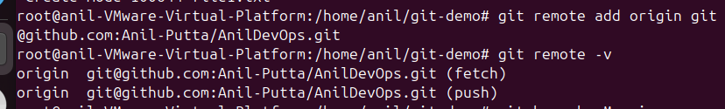
We can see the git main branch using git branch -m main
5.Push local commits to remote GitHub repository
git push -u origin main it push local file into main branch repository
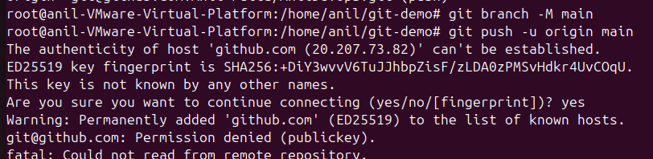

6.Create a new branch, make changes, and merge it back to main branch.
Creating the new branch with the command git checkout -b dev
git merge dev it merge the file into dev branch to main
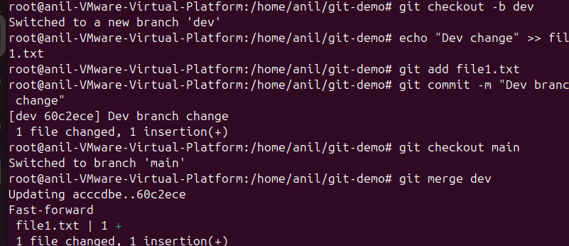

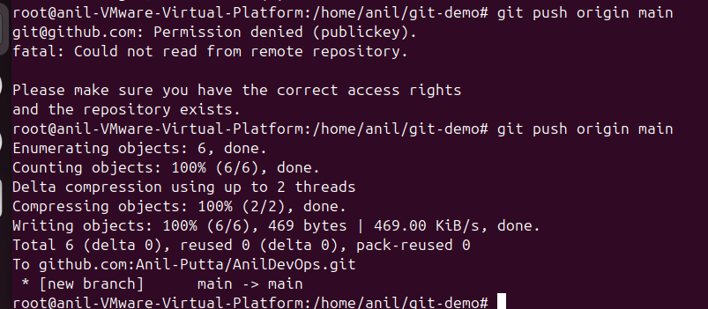
7.Practice rollback using git log, git reset, and git checkout.
Git log it shows all the commit of the git repository

